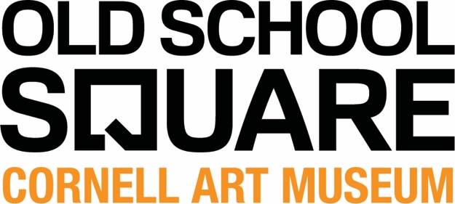

FOR IMMEDIATE RELEASE
Contact: Marusca Gatto, Director of Operations mgatto@oldschool.org (561.403.2956 Direct Line)
R.J. Rodriguez, Museum Associate/Unshaped Curator, rjrodriguezjr94@gmail.com (561-255-6485)
Old School Square, 51 N. Swinton Ave., Delray Beach, FL 33444
CornellArtMuseum.org
Facebook @OldSchoolSquareCornellArtMuseum
Instagram @CornellArtMuseum
Twitter @CornellMuseum
Please find photos for Unshaped exhibition, with appropriate identification, here: https://www.dropbox.com/sh/0g2ys88llyyalqk/AAC3jUfYHljTbwN7_eD5Xui6a?dl=0

Delray Beach, FL - May 24, 2019 - The Cornell Art Museum presents an upcoming group exhibition, Unshaped, in the Spotlight gallery for the month of June in conjunction with Pride Month. Unshaped is a group show curated by R.J. Rodriguez consisting of five (5) artists exploring the confines of mediums and concepts, asking for conversation on the physical and psychological boundaries we create and inherit. Opening on Friday June 7th with a reception beginning at 6pm in tandem with the First Friday Art Walk, Unshaped will be on view until the June 29th, 2019.

The featured artists identify as LGBTQ+, a demographic still marginalized both in public and in the museum space. This show is a reaction to a large part of art exhibitions still showcasing nearly exclusively white/male/heterosexual-identifying artists. Just as importantly, it wishes to bring focus to up-and-coming artists using out-of-the-box approaches to their practice.

Unshaped continues the Spotlight Gallery’s mission to foster connection and conversation amongst the artists and their community by allowing underserved and unseen art to be “spotlighted” and given a chance to be appreciated.

The Cornell Art Museum works to the collaborate with local are groups to curate, manage and promote art exhibitions to support and benefit non-profit children’s groups, student groups, art education groups, art scholarship organizations and other artists groups.

Cornell Art Museum’s Mission
The Cornell Art Museum strives to show nationally and internationally recognized contemporary artists who create innovative and thought-provoking works of art. The Museum exposes the greater Delray Beach and South Florida communities to artwork that is culturally relevant and exciting, hoping to foster creativity and inspire imagination.

About Old School Square
Old School Square is the center of arts & entertainment in downtown Delray Beach and has served as the community’s gathering place for over 25 years. The historic campus welcomes half a million people each year for programs, classes, events and rental activities and includes the intimate Crest Theatre (in the restored 1925 Delray High School building) the Cornell Art Museum (in the 1913 Delray Elementary building), and the Fieldhouse (c. 1925). The Pavilion, which opened in 2002, hosts outdoor concerts and shows. The Creative Arts School (2nd floor of the Crest Theatre building) offers art, photography and writing classes. Old School Square also serves as a venue for community, corporate, private and media events. For information on all programs and services, call 561-243-7922 or visit OldSchoolSquare.org.

Old School Square programs are sponsored in part by the City of Delray Beach, the Delray Beach Community Redevelopment Agency, the Board of County Commissioners, the Tourist Development Council, the Cultural Council of Palm Beach County, and the State of Florida through the Florida Department of State, Division of Cultural Affairs, and the Florida Council on Arts and Culture.

###

